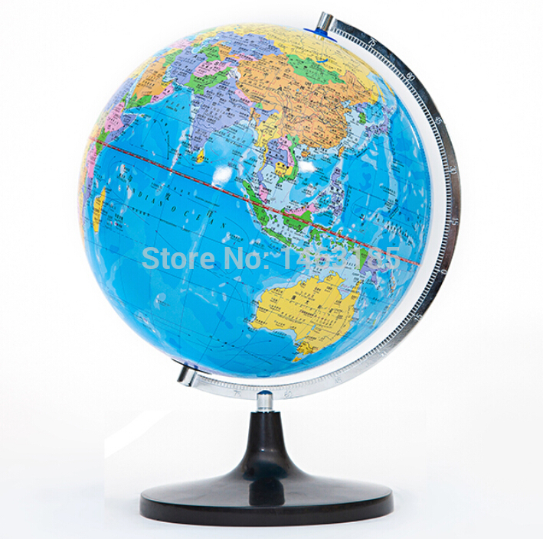

Bloom’s Digital Taxonomy/SAMR
EDUT: 521
ROMELIA HODGES

Teacher: Romelia Hodges Grade level: Social Studies Six Grade
Lesson title: Where did my stuff come from?

Lesson Overview
The title of this lesson is Where did my stuff come from? This lesson will cover the CA Common Core Standards Reading Standards for Literacy in History/Social Studies 6:3 and 6:7. The lesson is designed to engage students’ natural need to connect to the world around them. The student will use critical thinking skills to complete this assignment.
The Assignment
Students will be introduced to the concept of globalization. Globalization is define as a process of interaction and integration among the people, companies, and governments of different nations, a process driven by international trade and investment and aided by information technology. This process has effects on the environment, on culture, on political systems, on economic development and prosperity, and on human physical well-being in societies around the world.
Students will examine the production cycle of their own personal belongings (e.g. cell phone, iPad, laptop, clothing, etc.) and the relationship that product has to globalization. Students will research methods of discovery to find the relationship between their product and globalization. Students will present their findings in a digital presentation (Bloom’s e.g. Prezi, Powtoon, Emaze, etc.). (SAMR) Students will post on Google Maps the origins of their personal possessions and then meet and collaborate with a student from that destination. Student will use Google plus to meet the student and google docs to include personal perspective from collaborative partner. The students will include a short research essay in APA style detailing their research. The student will give and oral presentation to the class of three to five minutes. The presentation should have a good grasp of material and creative.
Essential question to guide study: Where did my stuff come from?
Understanding of the big idea: Globalization has a profound effect on the world that we occupy and in many areas that influence our lives. The impact is seen in economic development down the continuum to cultural differences among societies.
Key Knowledge: The student will enhance reading literacy and acquire an enhanced knowledge of research methods and the use of digital technology formats.
Important skills and what students should be able to do: The students should be able to explain the interrelationship between the productions cycles and globalization.

Part 1—Content Standards
For My stuff came from where lesson
CA Common Core Standards for Reading Standards for Literacy in History/ Social Studies 6-12
Standard 3: Identify key steps in a text’s description of a process related to history/social studies (e.g., how a bill becomes law, how interest rates are raised or lowered).
Standard 7: Integrate visual information (e.g., in charts, graphs, photographs, videos, or maps) with other information in print and digital texts.
Learning Objectives:
Learning Objective 1
Students create a presentation (e.g., Prezi, POWToon, or EMAZE) to document the origins of their personal possessions. Students will then research and write about the elements that contributed to the production of the item in Google docs.
Learning Objective 2
Students will post on Google Maps the origins of their personal possessions and then meet and collaborate with a student from that destination. Student will use Google plus to meet the student and google docs to include personal perspective from collaborative partner.
Part 2—Assessment Evidence
Teacher will use formal and informal assessment to evaluate the students completed work.
Formal assessment will include the grading of student’s digital presentation, pinning on collaborative Google Map, short research essay made in Google Docs and a three to five-minute oral presentation of the material in line with digital presentation.
Formal assessment will be graded by rubric system for each part of the assignment (rubric is included in the next session of this plan.)
Informal assessment will consist of daily participation grades base on the students’ preparedness, and class participation in class discussions about the project.
My research came from where? | 0 to 15 points  assignment is incomplete per teachers directions | 15 to 30 points  assignment is complete but there are some inaccuracies ( e.g., incomplete concepts) | 30 to 40 points  assignment is complete and accurate per teachers direction | 120 total possible points
Digital Presentation
Research Essay
Oral Presentation

Part 3—Learning Plan
Assignment requires use of the schools WIFI the acceptable use policy is in effect and all procedures will be strictly followed. The assignment requires use of various types of digital software (e.g., school’s media lab, classroom computers, students’ mobile devices, tablets and computers, and the use of the school’s media center).
The expected classroom time for this lesson is as follows.
- This lesson has a duration of ten full days
- Five complete days of 45 min class time
- Two class period for the use of the school’s media center
- Three days set aside for the student’s oral presentations
- Students will be required to work from home to supplement class time.

Part 4—Reflection
This lesson was created using the backwards design practice to have students engage in the concept of globalization. Student’s will follow the production cycle of products owned by the student. Some of my concerns are time zone differences and unforeseen technological difficulties. In addition, accommodation for students who are absent from class, or have an IEP/ 504 plan in place, Students who are digitally disadvantaged and need after school use of technology are able to check out a school laptop by submitting waiver form to media center.

After watching the self-paced lesson on this assignment, I quickly understood how I could incorporate Bloom’s/SAMR into this assignment. By incorporating Google software this assignment will provide students with an enhanced experience. This lesson plan included the use of Bloom’s Digital Taxonomy. It requires students to use presentation software to present their finding. By incorporating the collaborative use of Google Maps the assignment was modified and the students can see a visual synopsis of the classrooms statistics. In comparison, students are able to collaborate with students from the schools near the location where their item was made and get an oral history from a student who has a close personal connection with the item providing the students with a tangible real world perspective.

